OFFICIAL COORDINATION REQUEST FOR
NON-ROUTINE OPERATIONS AND MAINTENANCE

COORDINATION TITLE- 16 LGS 16 Discharge Pipe plug
COORDINATION DATE- September 23, 2016
PROJECT- Little Goose Lock and Dam
RESPONSE DATE- October 13, 2016

Description of the problem: The replacement of the powerhouse unwatering pumps and discharge piping are scheduled from September 4, 2018 to January 15, 2019. The drainage and unwatering pumps work together to keep the dam from flooding out due to leakage and dewater the various assets of the powerhouse such as the main units, fish pumps and fish channel. The replacement will require a mechanical pipe plug to be installed in the embedded unwatering pump discharge pipe located in the tailrace approximately 25 feet upstream of the south adult fishway entrance at a depth of 20 feet while the unwatering discharge isolation valve is replaced, as seen in the figure one.

Per dive safety regulations water velocities must not exceed 1 knot and there can be no entrapment such as a pump intake within 100 feet of the diver. Given the close proximity it is likely that the south adult fishway entrance will need to be closed during the installation and removal of the plug as well as shutting down the drainage and unwatering pumps themselves. Fish pumps one and possibly fish pump two will need to shut down during the work as they are within 100 feet of the diver. Unit priority will also need to be reassigned from units 1 and 2 being the primary to 5 and 6 in order to keep velocities below the threshold.

This work cannot be performed during the January/February fish ladder outage before or during the contract for the following reasons:

- Leakage flows into the drainage and unwatering sump are near peak levels during this time, which leaves an insufficient amount of time to install the plug, as both the drainage and unwatering pumps will be shut down and the powerhouse will be relying on the storage capacity of the sumps to keep from flooding. While some leakage can be diverted from the sump the inflow will still be too great.

- The current drainage pumps do not have the capacity to handle all the leakage inflow between December and April. During this time the unwatering pumps are needed to keep the power house from flooding and therefore cannot be taken off line.

Type of outage required: Fish pump one and two.

Impact on facility operation: South adult fishway entrance will be closed during the late afternoon and evening.

Dates of impacts/repairs: Two non-consecutive afternoon/evenings in early November.

Length of time for repairs: Maximum length of installation will be from 1400 to 0400 hours.

Expected impacts on fish passage: The adult fish system will be handicapped due to the closer of one of the three fishway entrances and reduced flows from having only one fish pump operational. However, the impact should be minimal as the work will be conducted after November 1st when 99% of fish have already passed the dam and from 1400 to 0400 hours when fish activity is at its lowest, see attached historical data.

Comments from agencies
From: Bill Hevlin - NOAA Federal
To: Setter, Ann L NWW
Cc: Bill Hevlin - NOAA Federal; Trevor Conder - NOAA Federal
Subject: [EXTERNAL] Re: Coordination: 16 LGS 15 Discharge Pipe plug
Date: Friday, September 23, 2016 9:50:22 AM
Hi Ann,
This relatively short delay in the tailrace during the late afternoon should not be a problem for the small number of
adult fall chinook migrants passing Little Goose during two days in November. Apparently the divers can operate
safely in the tailrace at night, this just seemed a little risky to me. We can talk more about this at the FPOM meeting
in October, but for now NOAA does not have a problem with this planned action.
Thanks for coordinating with us
Bill Hevlin
NOAA Fisheries

Final results

Please email or call with questions or concerns.
Thank you,

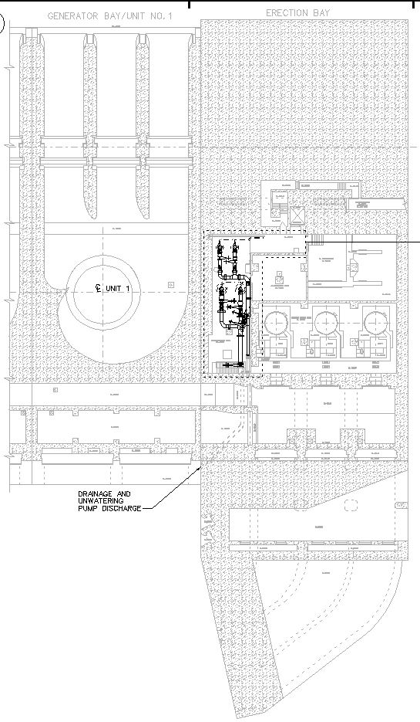
Fish Pump 2 Intake
Fish Pump 1 Intake
Isolation Valve to be Replaced
Unwatering Pumps
Drainage Pumps
South Fishway Entrance
Dive location
Drainage discharge located 2 feet above unwatering discharge

Figure 1 Plan View EL 498

Graph 1: Little Goose adult Chinook daily passage 2013, 2014, 2015 and 10 year daily average 2006-2015.
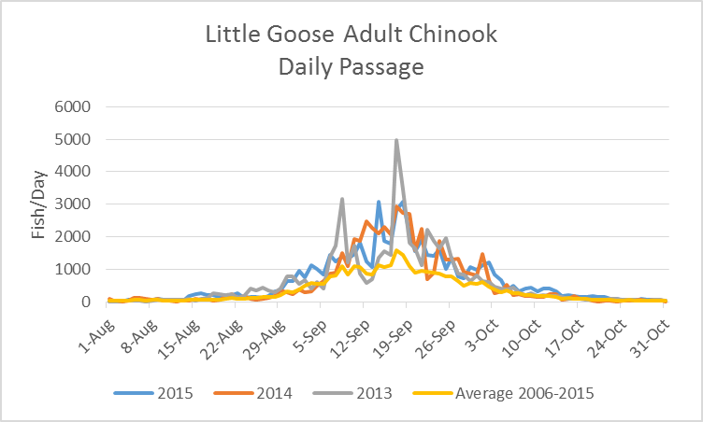

Graph 2: Little Goose adult Steelhead daily passage 2013, 2014, 2015 and 10 year daily average 2006-2015.
